**Francisco Javier Morales Cárdenas**

**Carné: 1223319**

Laboratorio 02

Parser generator

# Objetivo

* Explorar las herramientas para generación de código para los analizadores léxico y sintáctico.
* Introducir la traducción basada en sintaxis en la determinación de un valor resultante.

# Requerimiento

$$bexpr→bexpr or bterm | bterm$$

$$bterm→bterm and bfactor | bfactor$$

$$bfactor→not bfactor | \left(bexpr\right) | true | false$$

* Generar el analizador LALR(1) de forma manual para la gramática indicada.

Grafo LALR1:

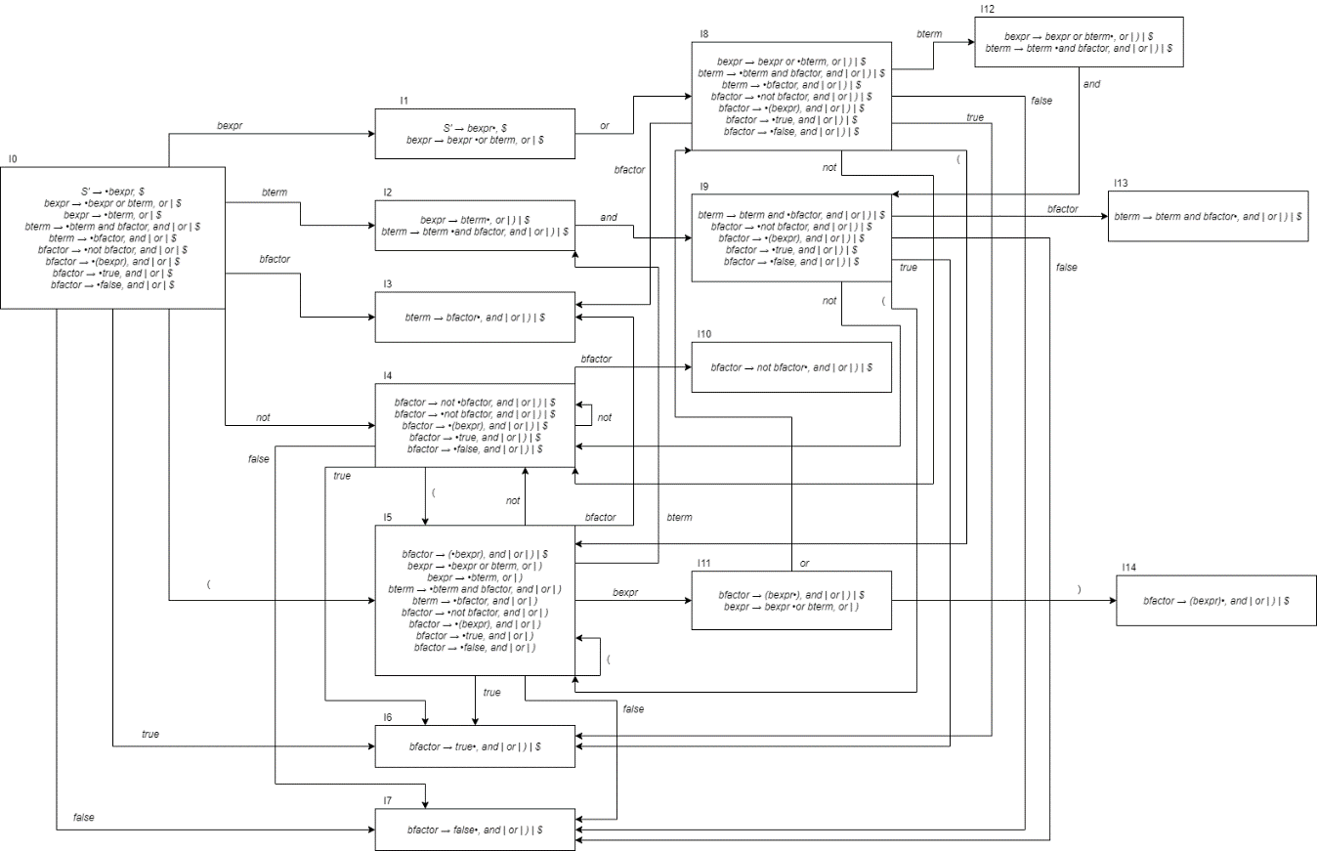

Tabla LALR1:

|  |  |  |  |  |  |  |  |  |  |  |  |
| --- | --- | --- | --- | --- | --- | --- | --- | --- | --- | --- | --- |
| Estado | Acción | | | | | | | | Goto | | |
| or | and | not | ( | ) | true | false | $ | bexpr | bterm | bfactor |
| 0 |  |  | S4 | S5 |  | S6 | S7 |  | 1 | 2 | 3 |
| 1 | S8 |  |  |  |  |  |  | Accept |  |  |  |
| 2 | R2 | S9 |  |  | R2 |  |  | R2 |  |  |  |
| 3 | R4 | R4 |  |  | R4 |  |  | R4 |  |  |  |
| 4 |  |  | S4 | S5 |  | S6 | S7 |  |  |  | 10 |
| 5 |  |  | S4 | S5 |  | S6 | S7 |  | 11 | 2 | 3 |
| 6 | R7 | R7 |  |  | R7 |  |  | R7 |  |  |  |
| 7 | R8 | R8 |  |  | R8 |  |  | R8 |  |  |  |
| 8 |  |  | S4 | S5 |  | S6 | S7 |  |  | 12 | 3 |
| 9 |  |  | S4 | S5 |  | S6 | S7 |  |  |  | 13 |
| 10 | R5 | R5 |  |  | R5 |  |  | R5 |  |  |  |
| 11 | S8 |  |  |  | S14 |  |  |  |  |  |  |
| 12 | R1 | S9 |  |  | R1 |  |  | R1 |  |  |  |
| 13 | R3 | R3 |  |  | R3 |  |  | R3 |  |  |  |
| 14 | R6 | R6 |  |  | R6 |  |  | R6 |  |  |  |

* Construir un programa con YACC/FLEX que permita calcular el resultado de la operación booleana según la gramática indicada.

El programa y todos sus archivos se encuentran en la carpeta yacc del repositorio.

* Cotejar el analizador creado manualmente con el generado mediante YACC/FLEX.

## Entrada

$$not\left(true or false\right) and true$$

## Salida

$$false (0)$$

*not (true or false) and true*

|  |  |  |  |
| --- | --- | --- | --- |
| **Pila Estados** | **Pila** | **Por leer** | **Acción** |
| 0 | *#* | *not (true or false) and true$* | Shift 4 |
| 0,4 | *not#* | *(true or false) and true$* | Shift 5 |
| 0,4,5 | *( not#* | *true or false) and true$* | Shift 6 |
| 0,4,5,6 | *true( not#* | *or false) and true$* | Reduce 7 |
| 0,4,5,3 | *bfactor( not#* | *or false) and true$* | Reduce 4 |
| 0,4,5,2 | *bterm( not#* | *or false) and true$* | Reduce 2 |
| 0,4,5,11 | *bexpr( not#* | *or false) and true$* | Shift 8 |
| 0,4,5,11,8 | *or bexpr( not#* | *false) and true$* | Shift 7 |
| 0,4,5,11,8,7 | *false or bexpr( not#* | *) and true$* | Reduce 8 |
| 0,4,5,11,8,3 | *bfactor or bexpr( not#* | *) and true$* | Reduce 4 |
| 0,4,5,11,8,12 | *bterm or bexpr( not#* | *) and true$* | Reduce 1 |
| 0,4,5,11 | *bexpr( not#* | *) and true$* | Shift 14 |
| 0,4,5,11,14 | *)bexpr( not#* | *and true$* | Reduce 6 |
| 0,4,10 | *bfactor not#* | *and true$* | Reduce 5 |
| 0,3 | *bfactor#* | *and true$* | Reduce 4 |
| 0,2 | *bterm#* | *and true$* | Shift 9 |
| 0,2,9 | *and bterm#* | *true$* | Shift 6 |
| 0,2,9,6 | *true and bterm#* | *$* | Reduce 7 |
| 0,2,9,13 | *bfactor and bterm#* | *$* | Reduce 3 |
| 0,2 | *bterm#* | *$* | Reduce 2 |
| 0,1 | *bexpr#* | *$* | **Accept** |